**Practical No. 15**

**Aim:** To implement B-trees/B+ trees and Indexing.

**Theory:**

B-Trees and B+ Trees are data structures used for indexing and searching in databases. They provide efficient methods for storing and retrieving data. They are designed to provide fast access to data, particularly in situations where data must be stored and managed on disk. A B-Tree is a self-balancing tree structure that maintains sorted data and is particularly useful for indexing. A B+ Tree is a variation of the B-Tree that is optimized for disk-based storage and retrieval.

**Queries:**

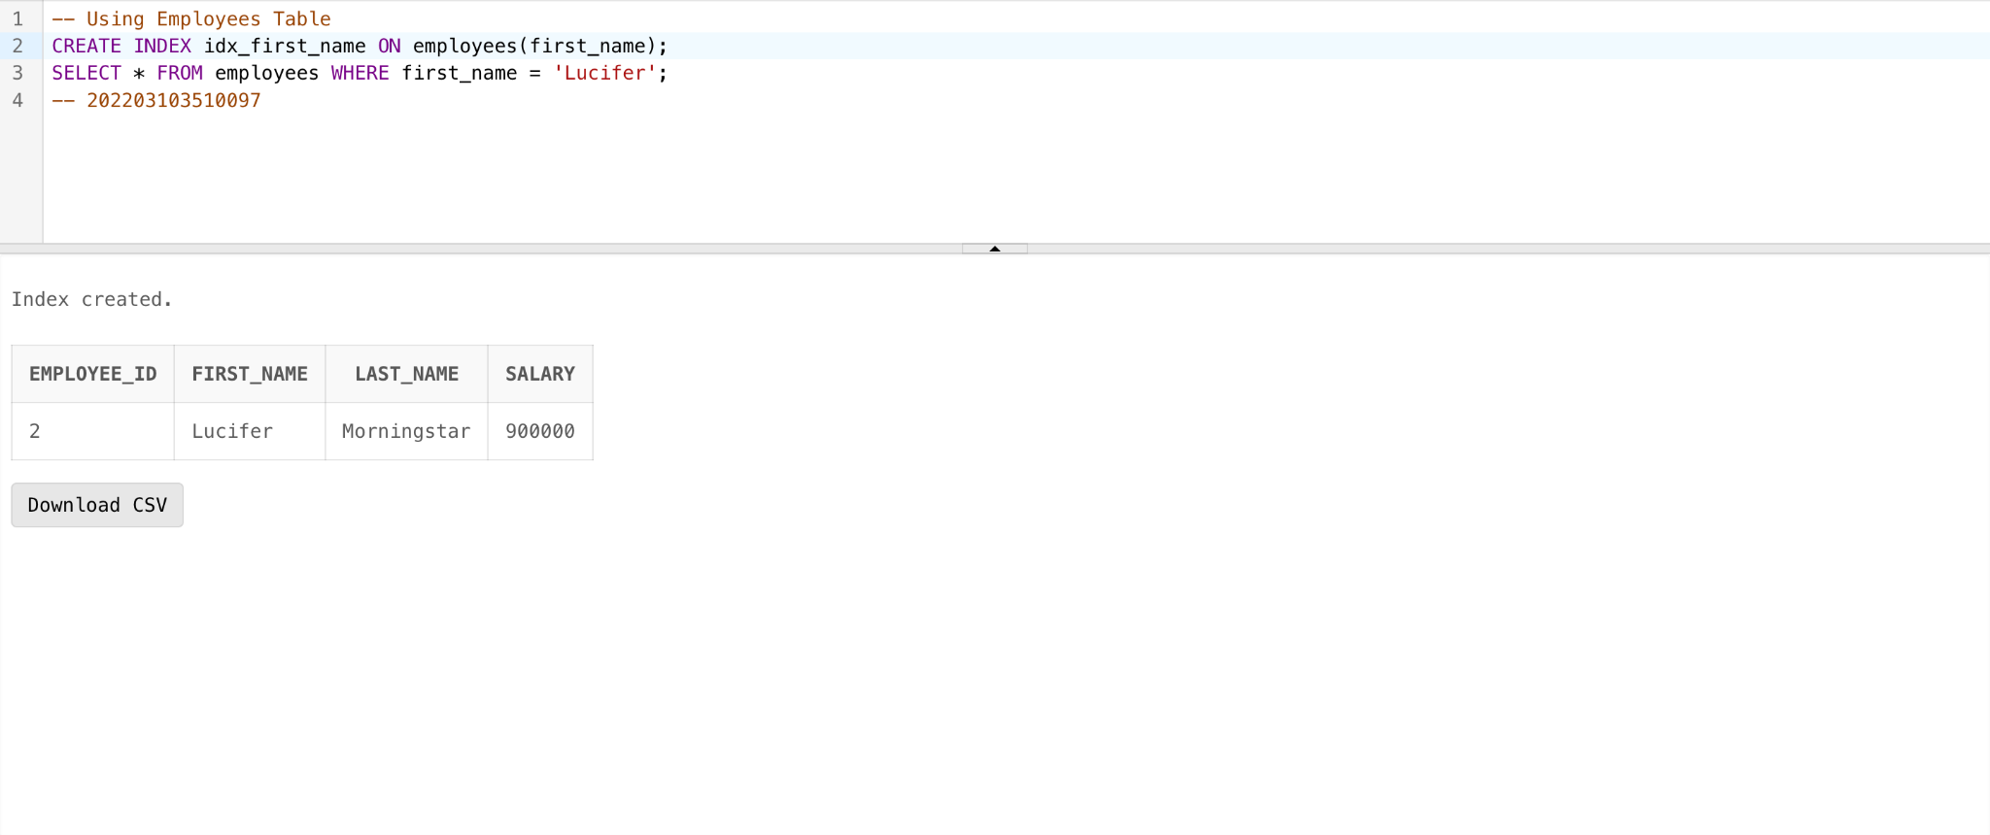

**Conclusion:** B-Trees, B+ Trees, and indexing are fundamental components of database management systems that play a critical role in optimizing data access and retrieval. They provide efficient methods for organizing and accessing data, particularly in large and complex database systems. The choice of indexing strategy and tree type depends on the specific requirements and workload of the database.